Class Activity 4

1. 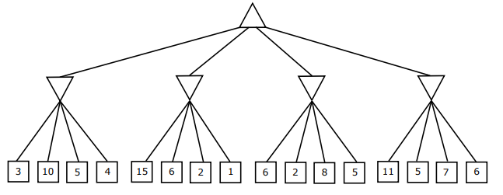Consider the following zero-sum game tree.

3

5

5

2

11

1. Fill in the minimax value of each node, assuming both players act optimally. How the game should be played?
2. Show the pruning of nodes from the game tree above through alpha-beta pruning. Explain the reason if no nodes can be pruned. Assume the search goes from left to right; when choosing which child to visit first, choose the left-most unvisited child.
3. 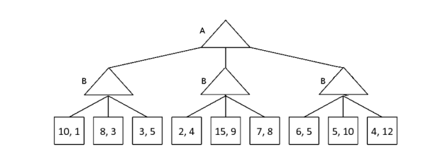Let us consider a non-zero-sum version of a game.

15, 9

4, 12

15, 9

3, 5

1. Fill in this non-zero game tree assuming each player is acting optimally.
2. Which nodes can be pruned from the game tree above through alpha-beta pruning? If no nodes can be pruned, explain why not.

No nodes can be pruned since there is always a chance for a greater value to be the next value.